ICT_Object Orientated Programming

Assessment task 5

Ciarán Maher 19th/March/2016

KTQ0855

Issue Log

- Testing of the application
  - Assessment task 4 - Test Log
  - Assessment task 4 - Test Plan
- Analysis of actual test results against expected results to identify discrepancies
  - Assessment task 4 - Test Log
- Recommendations for improvements to the program
- Change datatype from simple text file to database.
- Add Date/Time picker for further verification
- Add real-time price-check API
- Email flight booking/preview to the user (requires user to enter email address)
- Further validation of username/Airports to prevent numeric characters (as required)
- Documentation for use of the program by other programmers
  - Please see in-line comments for further details.
  - The Airline Booker 9001® uses JavaFx an “XML injection” plug-in for IntelliJ that is used worldwide for Android app development. This system combines java code with FXML files to build complex interface designs.
  - To execute the program 2 file paths must be edited in the FileHandler.
This can be done simply by editing the path String to the required path.
public static String path = "C:\\Users\\blue20\\Documents\\ICT_ObjectOrientatedProgramming\\Project\\AirlineBooker9001\\src\\gui\\";

  - Download IntelliJ Community here: https://goo.gl/SiArzB
  - Follow the instructions to ensure you have all of the required plug-ins, here:
https://goo.gl/ogkztQ
  - Launch IntelliJ and import the project by selecting new project from existing source. (Fig #1)
  - If you have all of the required plug-ins and the Java 1.8 SDK installed correctly, then just click next, using all of the default options and providing permission for any overwriting of existing files it uses for its plug-ins.
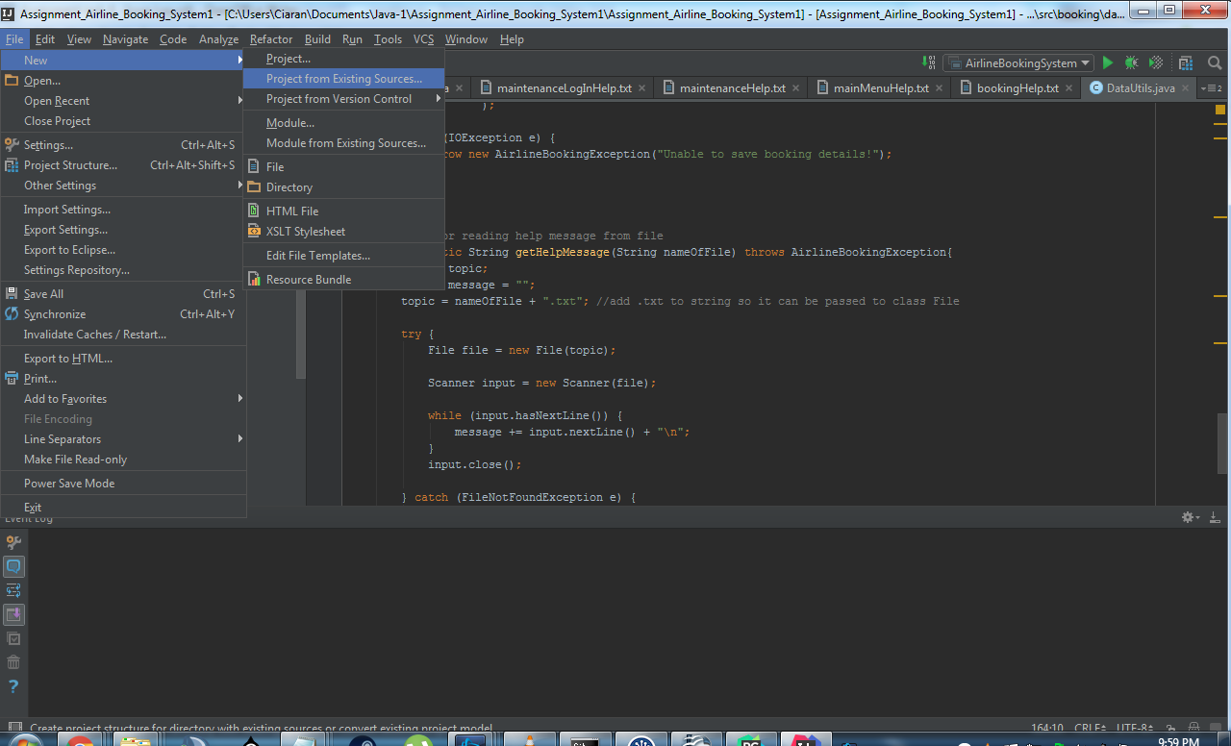
Fig #1
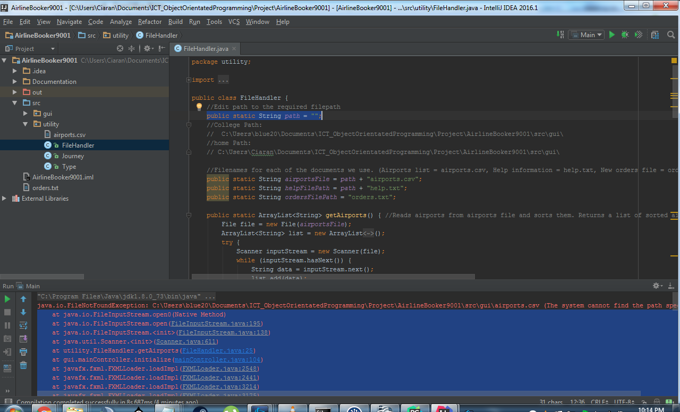
Fig #2
  - Before we launch for the first time, we'll need to edit the file paths in the file handler. Open the Utility > FileHandler.java and add the required path to the path string. (Fig #2)
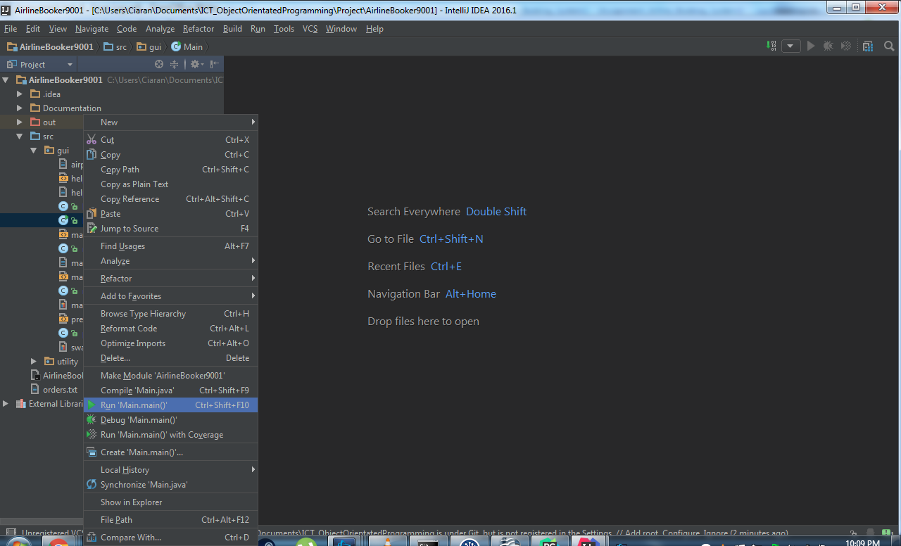
Fig #3
  - For first launch we must designate the entry point (but don't worry IntelliJ will remember next time). We do this by right clicking on the GUI > Main.java and selecting Run Main.main() (Fig #3)
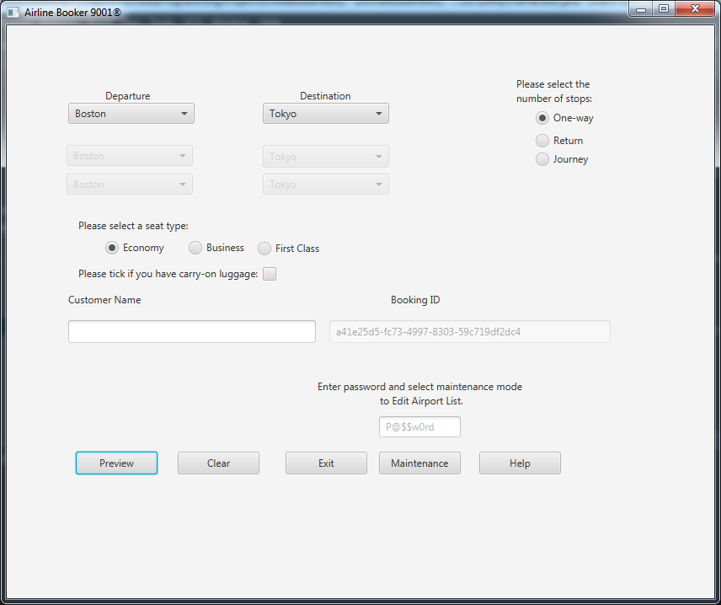
Fig #4
  - If everything is setup correctly, the program should launch. (Fig #4)
- A program with onscreen help to guide users of your program
  - Click on “Help” in the main window to view further usage details

